

Programming Fundamentals
Week 7
________________________________________________________________________
Learning Outcomes:
- Students should be able to define repetitive statements
- Students should be able to repeat a Set of Instructions for a specific number of times using counter loop.
- Students should be able to repeat a Set of Instructions for an unknown number of times using conditional loop.
- Students should be able to solve larger problems by decomposing it into smaller sub-problems and combining their solution to achieve final results using the Counter Loop
Instructions
∙ Use proper indentation to make your programs readable.
∙ Use descriptive variables in your programs (Name of the variables should show their purpose)
Loop

Introduction
In real-world life, we are working with a repetitive process like bowler throwing six balls in an over, cash counting in banks, a wheel revolving its spindle. For this purpose, we need a structure that maps these methods into programming which is loops.

Loop:

A process which repeats itself again and again is called loop. In our daily life, we encounter many situations where we have to decide the repeated process.
For example
- Software of the ATM machine is in a loop to process transaction after transaction until you acknowledge that you have no more to do.
- Software program in a mobile device allows user to unlock the mobile with 5 password attempts.
- You put your favorite song on repeat mode.

Before implementing loops, let's recall the concepts that you were taught in the earlier class.
There are 2 types of Loops.
- Counter Loops
- Conditional Loops

Counter Loop:
In Counter Loop, the program knows beforehand about how many times a specific instruction or set of instructions will be executed. In C++ programming language, for loop is used as a counter loop.
Syntax of For Loop:

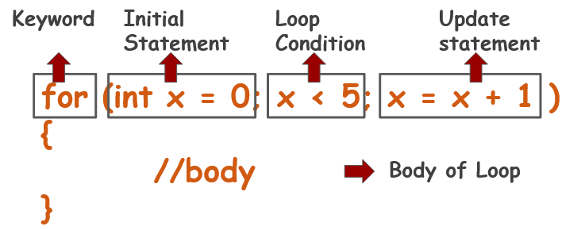
Flow of For Loop:
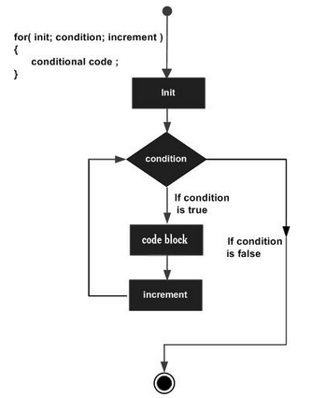

Example #1:
Write a code showing that display counting from 1 to 10.
Solution
#include <iostream>
using namespace std;
main()
{
for(int i = 1; i<=10; i= i+1)
{
cout << i << endl;
}

}

The code produces the following output
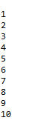

Explanation:
Iteration | Variable | i <= 10 | Action
1st | i = 1 | True | 1 is printed. i is increased to 2.
2nd | i = 2 | True | 2 is printed. i is increased to 3.
3rd | i = 3 | True | 3 is printed. i is increased to 4.
4th | i = 4 | True | 4 is printed. i is increased to 5.
5th | i = 5 | True | 5 is printed. i is increased to 6.
6th | i = 6 | True | 6 is printed. i is increased to 7.
7th | i = 7 | True | 7 is printed. i is increased to 8.
8th | i = 8 | True | 8 is printed. i is increased to 9.
9th | i = 9 | True | 8 is printed. i is increased to 10.
10th | i = 10 | True | 10 is printed. i is increased to 11.
11th | i = 11 | false | The loop is terminated

Example 1 was an example of Independent Iterations which means the result of previous iteration was not required for next iterations. However, there are set of problems that require the result from previous iterations. Such iterations are called dependent iterations.
Let’s see the Examples of Dependent Iterations.

Example #2:
Calculate the sum of first 5 natural numbers.
Remember: Before writing the program, first step is to identify the pattern within the sub problem such that this pattern can be written as a generic expression or set of generic expressions.
Solution
#include <iostream>
#include<iostream>
using namespace std;
main()
{
int sum = 0;
for(int i = 1; i<=5; i= i+1)
{
sum = sum + i;
}
cout << sum << endl;
}

The code produces the following output

Example # 3:
Write a code that prompts the user to input length of Fibonacci series and display the series.
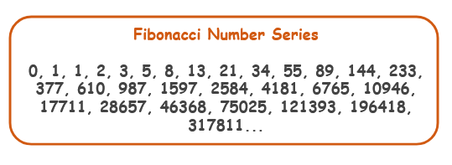
Solution
#include <iostream>
using namespace std;
main()
{
int n1 = 0, n2 = 1, next;
int n;
cout << "How many numbers of Fibonacci Series you want to print: ";
cin >> n;

cout << n1 << ", ";
cout << n2;
for(int x = 1; x < n - 1; x = x + 1)
{
next = n1 + n2;
cout << ", " << next;
n1 = n2;
n2 = next;
}
}

The code produces the following output

Example # 4:
Derive logic to calculate total number of digits in a number.

Solution
#include<iostream>
using namespace std;
int main() {
int n, count = 0;
cout << "Enter number: ";
cin >> n;

for(int i = n; i > 0; i = i / 10) {
count = count + 1;
}

cout << "Total Number of Digits: " << count;
return 0;
}
The code produces the following output


Challenge#1:
Print multiplication table of 24, 50 and 29 using loop.
TestCase:
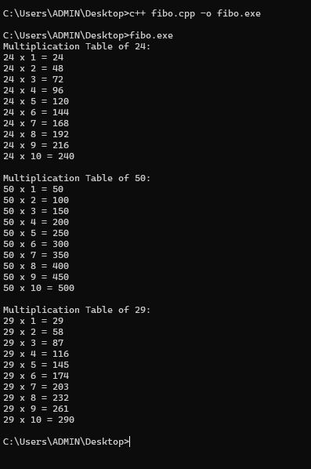

Challenge#2:
Find the frequency of a digit in a number.
Test Cases:
frequencyChecker(566960, 6) 3

frequencyChecker(566960, 5) 1

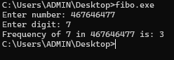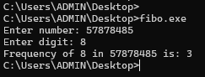
Congratulations, you have performed all the tasks using the For Loop. Now let’s move towards conditional Loops.
Conditional Loop:
Conditional loops help to repeat a set of instructions until some condition is true. There are two common places for it use.
- Reading an unknown amount of input from the user
- Validating input.
C++ provides a while loop that is used as a conditional loop.

Syntax of While Loop
The syntax of a while loop in C++ is
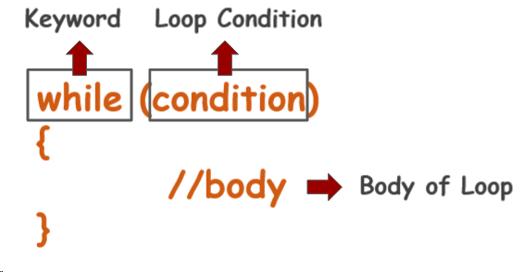
The condition may be any expression, and true is any non-zero value. The loop iterates while the condition is true. When the condition becomes false, program control passes to the line immediately following the loop.

Flow of While Loop

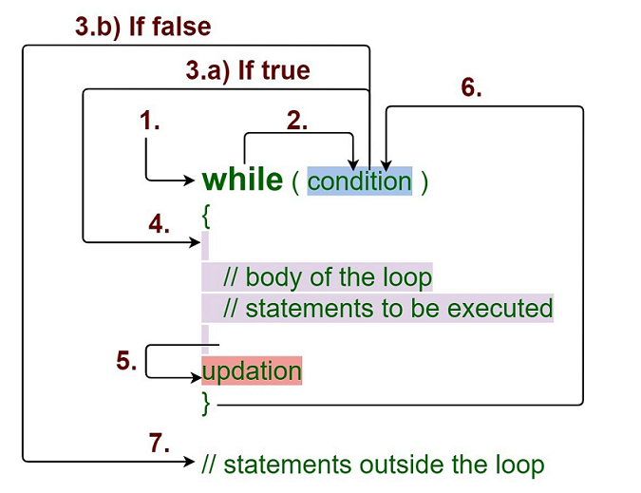
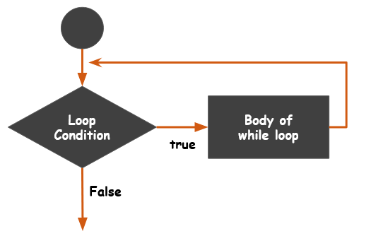
Example #1: Print a message “I am happy” until user presses “y” or any key to exit.

Solution
#include <iostream>
using namespace std;
main()
{
char ch = 'y';
while(ch == 'y')
{
cout << "I am Happy" << endl;
cout << "Press y to continue or any key to exit" << endl;
cin >> ch;
}
}

The code produces the following output
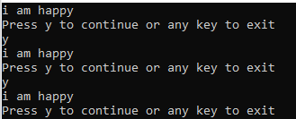

Let’s understand how we can validate input using a while loop with a working example.

Example #2:
Suppose the requirement is to enter a positive number but if the user enters negative number then an error message is shown and the user is again asked to enter a positive number.
Solution
#include <iostream>
using namespace std;
main()
{
int value;
cout << "Please enter a Positive Number: ";
cin >> value;
while (value <= 0)
{
cout << "Error: " << value << " is not a Positive Number." << endl;
cout << "Please enter a Positive Number: ";
cin >> value;
}
cout << "Program Ends" << endl;
}

The code produces the following output
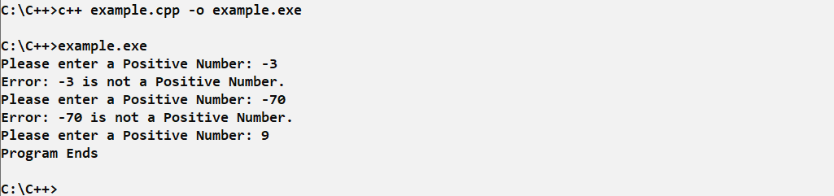

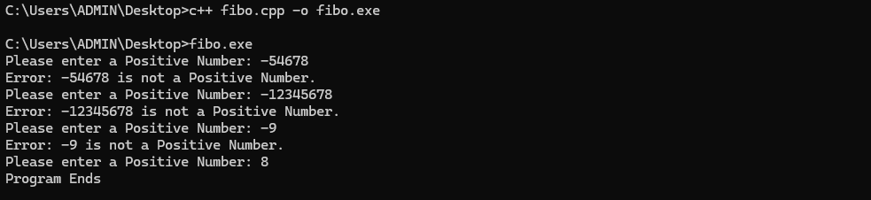

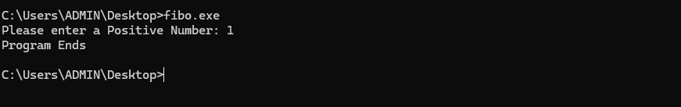

There are many problems that you can solve with both for loop or while loop. It’s up to you which loop you want to use in which you are more comfortable.
Let’s see the first example of for loop.

Example # 3:
Display counting from 1 to 10.
Solution with For Loop | Solution with While Loop
#include <iostream>  using namespace std;  main()  {  for(int i = 1; i<=10; i= i+1)  {  cout << i << endl;  }  } | #include <iostream>  using namespace std;  main()  {  int i = 1;  while (i <= 10)  {  cout << i << endl;  i = i + 1;  }  }
The code produces the following output


Example #4:
Calculate the sum of first 5 natural numbers.
Remember: Before writing the program, first step is to identify the pattern within the sub problem such that this pattern can be written as a generic expression or set of generic expressions.
Solution with For Loop | Solution with While Loop
#include <iostream>  #include<iostream>  using namespace std;  main()  {  int sum = 0;  for(int i = 1; i<=5; i= i+1)  {  sum = sum + i;  }  cout << sum << endl;  } | #include <iostream>  #include <iostream>  using namespace std;  main()  {  int i = 1, sum = 0;  while (i <= 5)  {  sum = sum + i;  i = i + 1;  }  cout << sum << endl;  }
The code produces the following output

Congratulations, you have practiced and learned the fundamental concepts of For and While Loop.
Let's start the challenges now. You can use any loop.
Challenge 1:
Write two separate functions to find greatest common divisor (GCD) or highest common factor (HCF) of given two numbers.
Greatest Common Divisor (GCD) or Highest Common Factor (HCF) of two positive integers is the largest positive integer that divides both numbers without remainder.
Least Common Multiple (LCM) of two integers is the smallest integer that is a multiple of both numbers.
Hint:
LCM(a, b) = (a * b) / GCD(a, b)

TestCases:

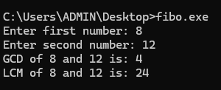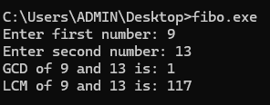

Nested For Loop:
A nested loop has one loop inside of another. These are typically used for working with two dimensions such as printing stars in rows and columns as shown below. When a loop is nested inside another loop, the inner loop runs many times inside the outer loop. In each iteration of the outer loop, the inner loop will be re-started. The inner loop must finish all of its iterations before the outer loop can continue to its next iteration.

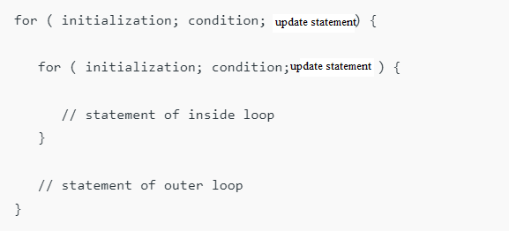

Example #1 Write a program in C++ to display the pattern like right angle triangle using an asterisk.
*
* *
* * *
* * * *
* * * * *

Solution
With Nested For
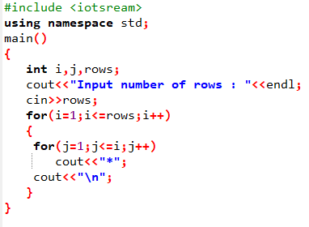
The code produces the following output
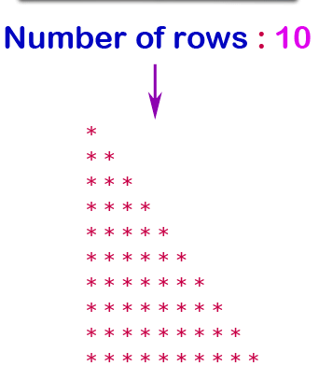
The code produces the following output

Challenge#1: Write a program in C++ to display the pattern like diamond using an asterisk.

*
**
***
****
*****
*****
****
***
**
*
Challenge#2: Write a C++ program to create a simple University Management System using basic programming concepts.
Your program must include the following requirements:
- The program should allow the user 3 login attempts using a for loop.
- The correct login credentials are:
  - Username: admin
  - Password: 1234
- If the username and password are correct using a logical operator (&&), the program should display "Login Successful" and show the main menu.
- After successful login, display the following menu:
  - 1 → Add Student
  - 2 → View Student
  - 3 → Add Course
  - 4 → Exit
- When the user selects Add Student, the program should ask for student name and age and store them temporarily in variables.
- When the user selects View Student, the program should display the stored student information.
- When the user selects Add Course, the program should ask for a course name and store it temporarily.
- If the user selects Exit, the program should terminate.
- The program must use:
  - if–else statements
  - logical operators (&&, ||, !)
  - for loop

Code
#include <iostream>
using namespace std;
int main()
{
string username, password;
string studentName = "";
int studentAge = 0;
string courseName = "";
int choice;
for(int i = 1; i <= 3; i++)
{
cout << "Enter Username: ";
cin >> username;
cout << "Enter Password: ";
cin >> password;
if(username == "admin" && password == "1234")
{
cout << "Login Successful"<<endl;
break;
}
else
{
cout << "Wrong Login"<<endl;
}
if(i == 3 && !(username == "admin" && password == "1234"))
{
cout << "Too many attempts. Program End."<<endl;
return 0;
}
}
for(int i = 1; i <= 5; i++)
{
cout << endl<<"---- University Management System ----"<<endl;
cout << "1. Add Student"<<endl;
cout << "2. View Student"<<endl;
cout << "3. Add Course"<<endl;
cout << "4. Exit"<<endl;
cout << "Enter Choice: ";
cin >> choice;
if(choice == 1)
{
cout << "Enter Student Name: ";
cin >> studentName;
cout << "Enter Student Age: ";
cin >> studentAge;
cout << "Student Added Successfully"<<endl;
}
else if(choice == 2)
{
if(studentName != "")
{
cout << "Student Name: " << studentName << endl;
cout << "Student Age: " << studentAge << endl;
}
else
{
cout << "No Student Record Found"<<endl;
}
}
else if(choice == 3)
{
cout << "Enter Course Name: ";
cin >> courseName;
cout << "Course Added: " << courseName << endl;
}
else if(choice == 4)
{
cout << "Program Exit"<<endl;
break;
}
else
{
cout << "Invalid Choice"<<endl;
}
}
}

The code produces the following output
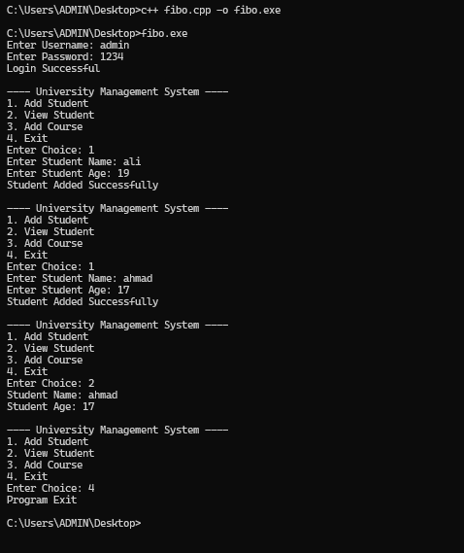
Challenge#3: Write a C++ program to simulate a simple ATM Management System using basic programming concepts.

Requirements:
- The program should allow the user 3 attempts to enter the ATM PIN using a for loop.
- The correct PIN is 1234.
- If the correct PIN is entered using a logical operator (==), the program should display “Login Successful” and show the ATM menu.
- After successful login, display the following options:
  - 1 → Check Balance
  - 2 → Deposit Money
  - 3 → Withdraw Money
  - 4 → Exit
- If the user selects Check Balance, the program should display the current account balance.
- If the user selects Deposit Money, the program should ask for an amount and add it to the balance.
- If the user selects Withdraw Money, the program should ask for an amount and deduct it from the balance only if sufficient balance is available.
- If the balance is insufficient, display “Insufficient Balance”.
- If the user selects Exit, the program should terminate.
- The program must use:
- if–else statements
- logical operators (&&, ||)
- for loop
TestCase:
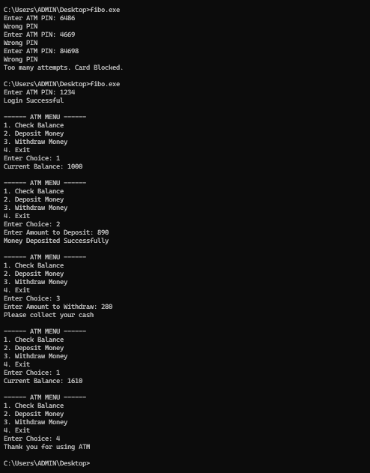

Congratulations, you have practiced a lot and now have complete knowledge of loops.

